STEP 1: PUT MODULE INTO UPDATE MODE
- Disconnect power and USBC
- Plug them in again, and within 3 seconds press and hold buttons 7 and 8:

When you hear beep for 3 seconds, it is in update mode.

STEP 2: RUN IAP SOFTWARE
- Select COM port and baud rate, then select Connect
- Enter the details as below.
Set address as below (VERY important)
Set the .bin file path.
Select Install

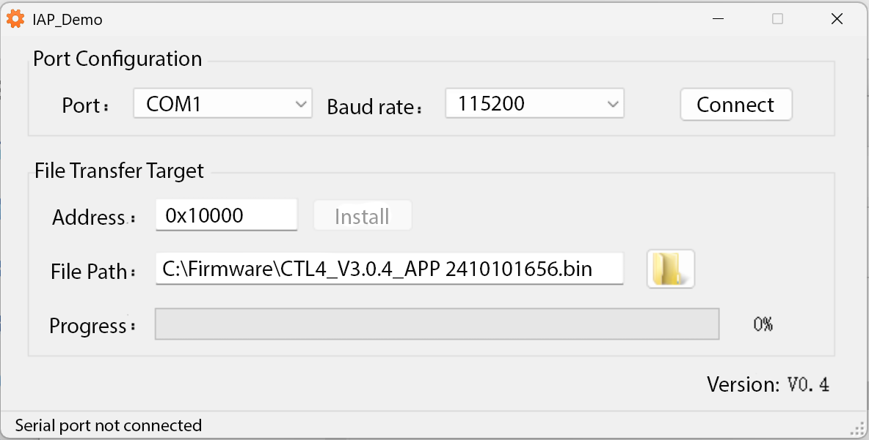
Alternating flashing red and blue lights indicates success. The device will put itself into normal mode.

